Chat with Big Ed

Task 1: PREDICT

With a partner, spend time reading the code below. PREDICT exactly what you think will happen. This is not a test, so don’t worry about your prediction being correct.

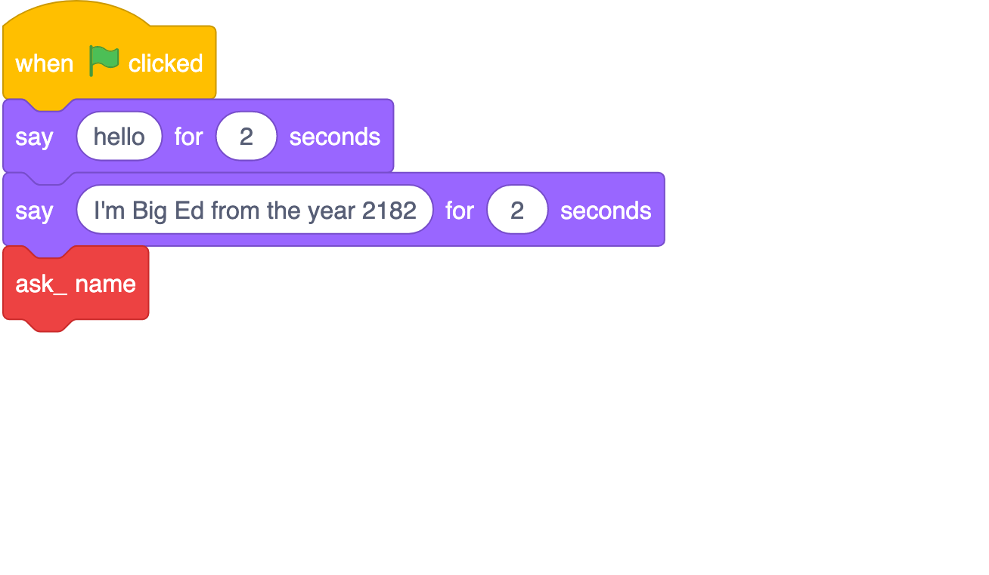 | 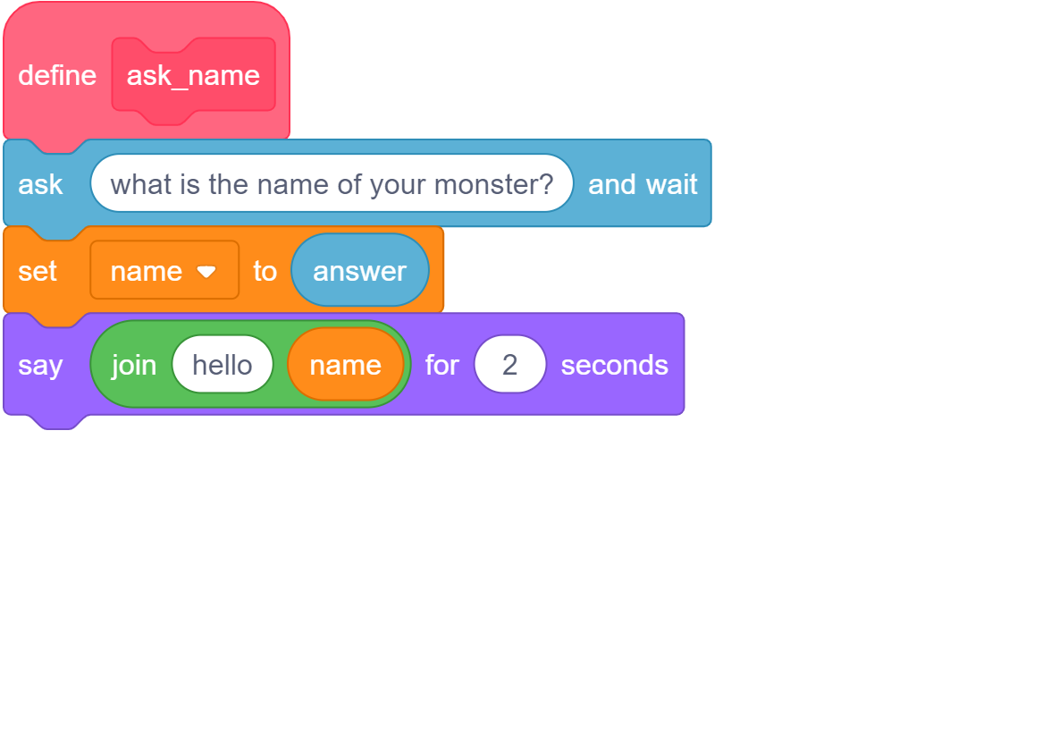

What do you PREDICT will happen when the Green flag is clicked?

Questions | Your answers ▿
Now run the code.

- Were your predictions correct?

- Did anything surprise you about what happened when the code was executed?

- Did you miss anything out? If so, what?

Task 2: INVESTIGATE

Open the following Scratch program and select See inside

ncce.io/biged1

Answer the following questions with your partner by experimenting with the code in order to investigate how it works.

Questions | Your answers ▿
How do the following two blocks of code relate to each other?

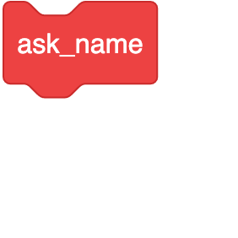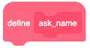
Temporarily remove the following block:
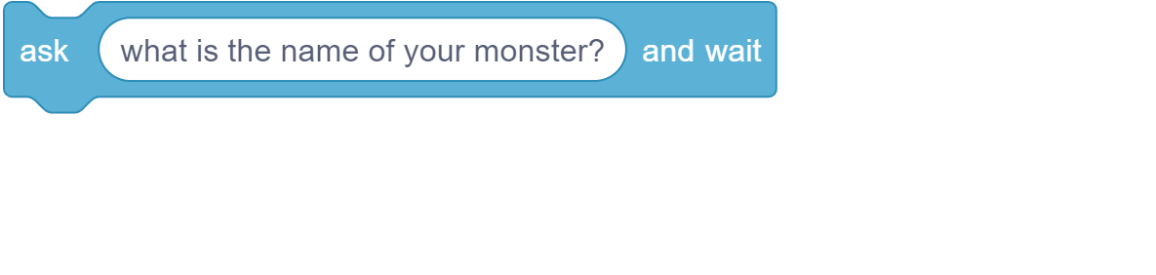
What has this changed about the program when you run it?
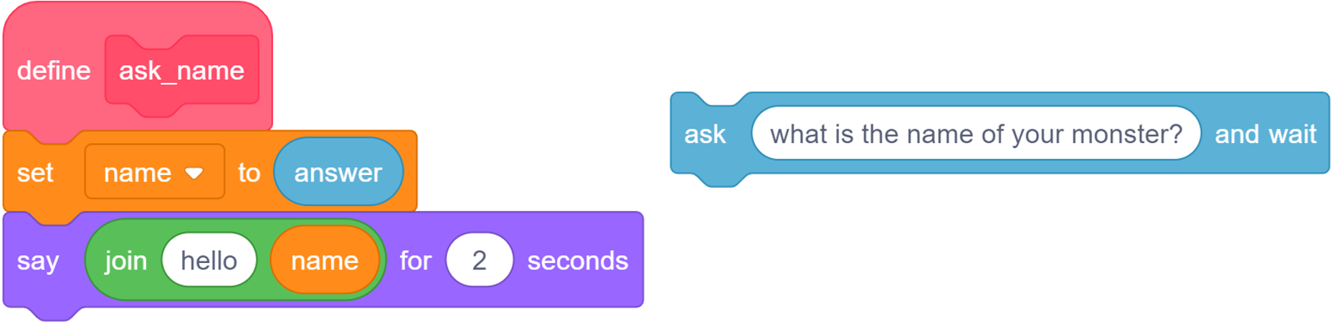

Why do you think this is?

Below define ask_name, there are two variables being used. What are their names?
Now place the ask what is your name and wait block back into the code, but place it after the set name to answer block:
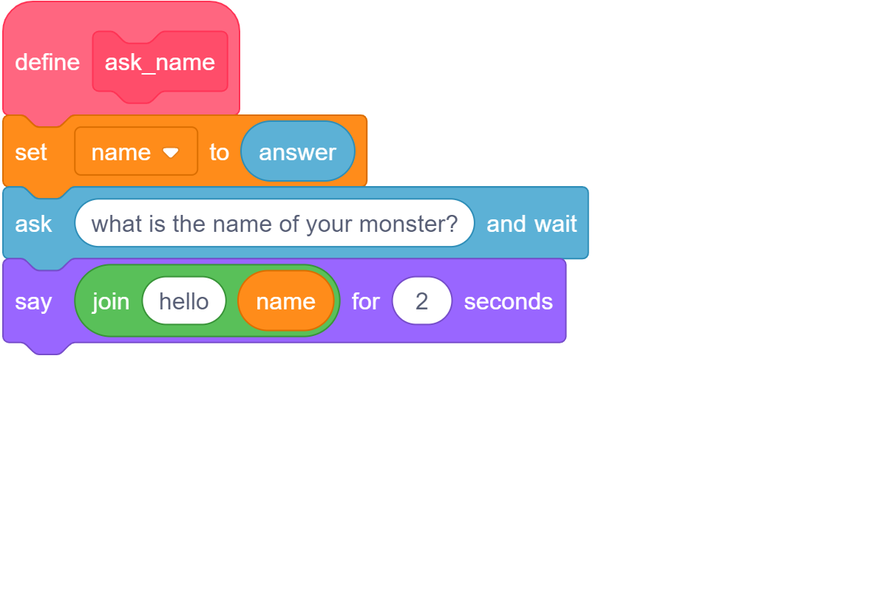
Why do you think it only says “Hello” and not “Hello “ and the name you entered?

What can you learn from this?

Task 3: Modify

Now that you have explored how the game works, your task is to complete the parts of the program that aren’t currently working.

3.1: The music question

All of the code needed to make Big Ed ask about your favourite music has been included in the program. Place the blocks on the right-hand side into the appropriate places in the subroutine.

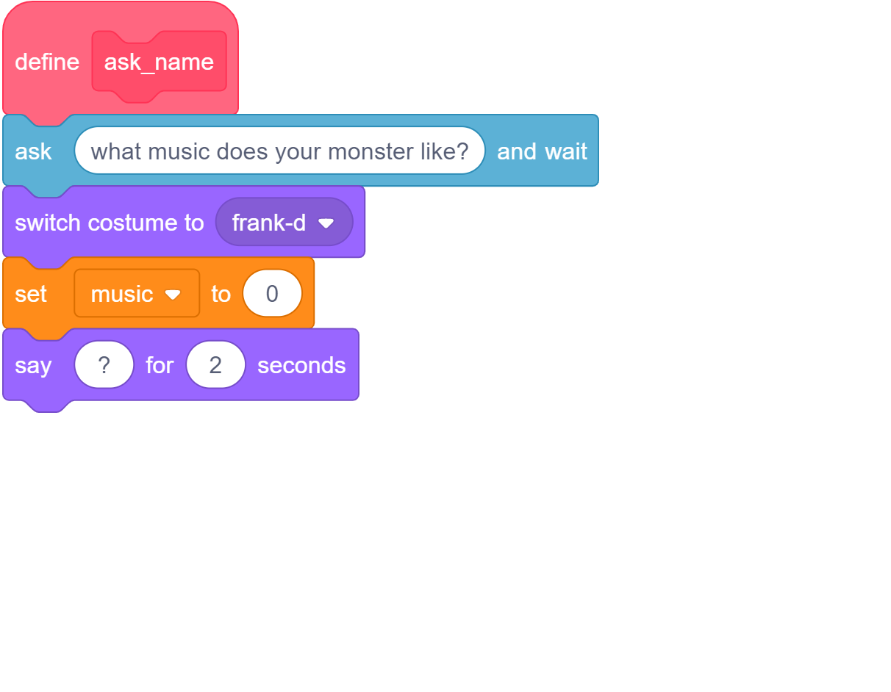 | 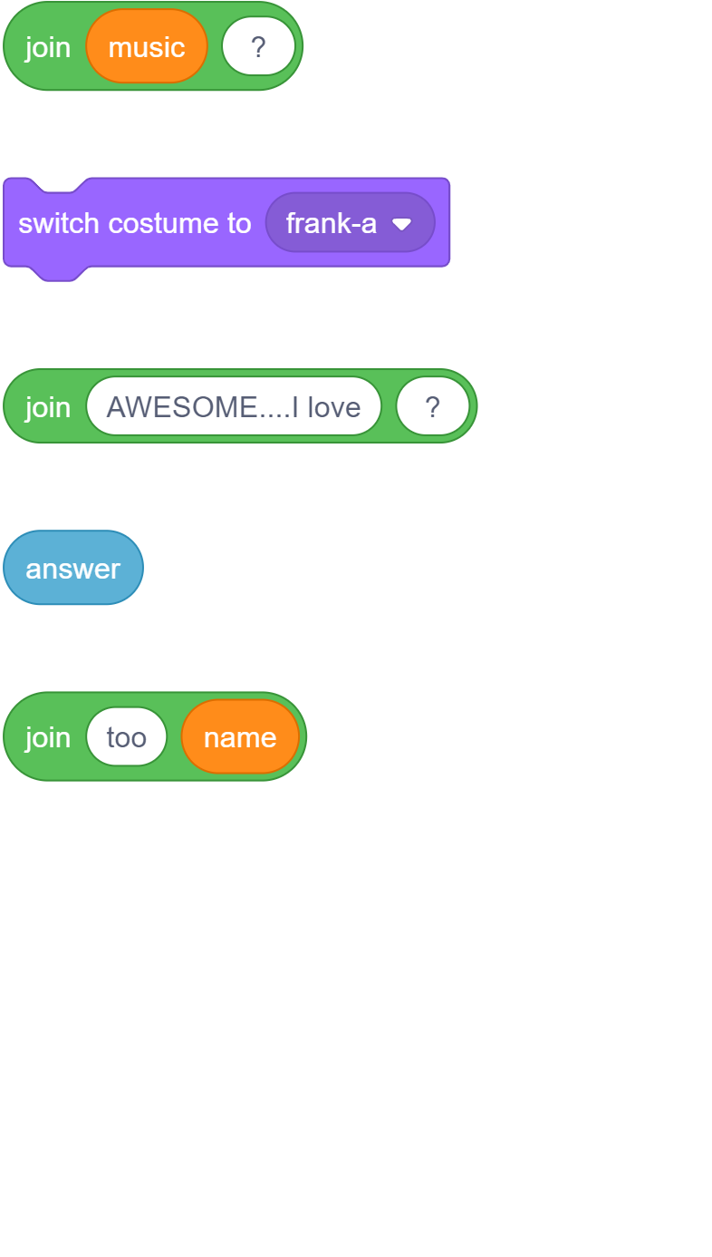

Questions | Your answers ▿
When you have completed your code, take a screenshot, and place it in the box to the right.
Errors in your code are known as ‘bugs’. The task of fixing these errors is known as ‘debugging’.

Did your code work the first time?

If anything didn’t work:
- Explain what didn’t work
- How did you debug the errors?

3.2: The age question

Complete the ask_age subroutine. The subroutine has two lines of code provided. The subroutine should use the age variable to store the answer. Big Ed should then say the following two lines:
“Wow [age]” for 2 seconds
“Your monster is much older than me in the year 2182” for 2 seconds

Hint: Use the same structures from the previous two questions to build this question.

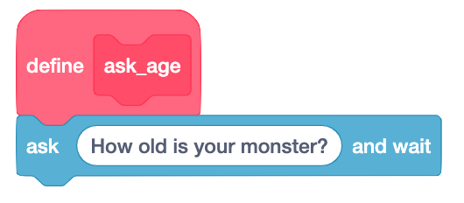

Questions | Your answers ▿
When you have completed your code, take a screenshot and place it in the box to the right.
Did your code work first time?

If anything didn’t work:
- Explain what didn’t work
- How did you debug the errors?

Explorer task

Use the code blocks to add a new question to be asked about your favourite sport or hobby.

Resources are updated regularly — the latest version is available at: ncce.io/tcc.

This resource is licensed under the Open Government Licence, version 3. For more information on this licence, see ncce.io/ogl.

